# LAB TASK 7

## TASK 1;

#include <iostream>

using namespace std;

int main()

{

//// LAB TASK 1

int x [10];

cout<<"Please enter the ten integers"<<endl;

for(int i=0; i<10; i+=1){

cin>>x[i];}

for(int j=0; j<10; j+=1){

cout<<x[j]<<" ";}

RESULTS:

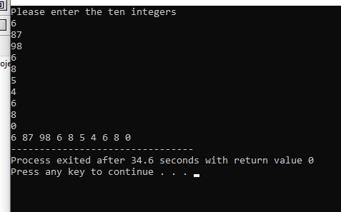

## TASK 2:

int a [5] = {};

int sum;

int p = 1;

cout<<"Please enter the 5 integers"<<endl;

for(int i=0; i<5; i+=1){

cin>>a[i];}

for(int i=0; i<5; i+=1){

sum = sum+a[i];}

for(int j=0; j<5; j+=1){

p = p*a[j];}

RESULTS:

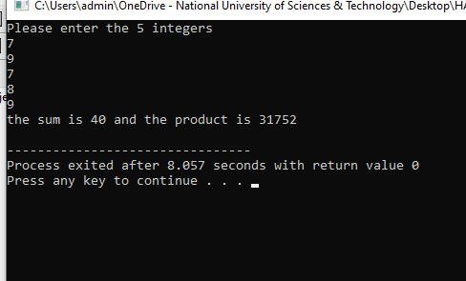

TASK 3:

#include <iostream>

using namespace std;

int main(){

cout<<"Please enter the number of rows"<<endl;

cin>>r;

if(r%2==0){ cout<<"Please enter an odd number"<<endl; return 0;}

else{

char b[r];

int h = r/2;

for(int i=0; i<=r; i+=1){b[i]=' ';}

for(int j=0; j<=h; j+=1){

b[h-j]='*';

b[h+j]='*';

for(int z=0; z<r; z+=1){cout<<b[z];}

cout<<endl; }

for(int q=0; q<h; q+=1){

b[r-1-q]=' ';

b[q]=' ';

for(int s=0; s<r; s+=1){cout<<b[s];}

cout<<endl;

}

}

return 0;

}

RESULTS:

